**POLYTECHNIC UNIVERSITY OF THE PHILIPPINES**

College of Engineering Department of Computer Engineering

A. Mabini Campus, Anonas St., Sta. Mesa, Manila, Philippines, 1016

**Effect of Automatic Disinfection Box Using Ultra Violet Light on Microbial Growth of Microorganisms**

Engr. Jonathan C. Manarang1, **, Engr. Pedrito M. Tenerife Jr.2 **, John Christopher B. Bagas3, *, Charles Adriane S. Guerrero4, *, Marcus M. Saralde5, *

*\*\*Faculty, *Proponents, Department of Computer Engineering, PUP College of Engineering*

# ABSTRACT

**Researchers aim to determine the effectiveness of ultra violet lights in disinfecting using an automatic disinfection box. Researchers ought to find the significant difference for disinfecting between UV-based disinfectant and alcohol-based disinfectant, the significant effect of UV intensity, and the difference among the different duration in terms of its effectiveness. Researchers conduct streak plate and spread analysis on four similar pens under normal condition. Effectiveness of UV based and Alcohol based disinfectant were measured based on number of colonies in different treatments. Different treatments were replicated thrice and were compared to a baseline treatment wherein the agar plate was not exposed to UV or Alcohol. Gathered data are analyze using Two-sample & one-sample Wilcoxon test and Kruskal-Walis test. Four-point Likert scale are use to describe the device in terms of necessity, quality, price-quality ratio and approval. Results revealed that the baseline treatment was relatively higher compared to Alcohol based and UV based treatments. This suggests that Alcohol based and UV based disinfectant were more effective in terms of bacterial inhibition. Study shows that there is enough evidence to conclude that UV and Alcohol based disinfectant exhibit no significant difference when it comes to their effectiveness, UV intensity has a significant effect in terms of effectiveness, the different durations (10, 20, 30 seconds) of UV exposure show no significant difference in terms of effectiveness. Responses shows that the automatic disinfection meets current pandemic situation extremely well, has a very high quality, in terms of price has an above average value for money and the respondents are very satisfied using the device. The researchers recommend develop a real-time UVC dosage monitor module that shows the current UVC dosage of the device producing and a proper item counter.**

***Keywords***: *Automatic Disinfection, COVID19, Ultra Violet, Microbial Growth, Microorganisms*

# INTRODUCTION

In December of 2019 in Wuhan, China, an outbreak occurred due to the spread of the Novel Coronavirus. The virus spread at rapid rate and infect many people. Causing a great number of hospitalizations and casualties. The virus spread through-out the globe and recognized as global pandemic affecting more than 220 countries (Worldometer, 2021).

According to Kodoth et. Al. (2020), the society need to be cautious of other dangerous microorganisms that spread illness in addition to viruses. Humans are constantly in contact with germs and bacteria. Many surfaces and objects we come in contact with every day are covered in microorganisms that are potentially harmful to normal people with normal immunity. When poor hygiene habit is practiced, microorganisms can be passed from person to person (Francisco, 2022). These could potentially cause sickness and may escalate to something serious.

The Coronavirus cause a significant impact on disinfectant industry. Sudden rise in demand for sanitizers and disinfectant as a preventive measure against the virus has change the dynamic of the market (Reports and Data, 2020). The disinfectant demand imposes a challenge and concern to supply chain.

According to NationalAcademies (2021), ultraviolet lights specifically UVC, have the trait to inactivate SARS-CoV-2 and shows effectivity against reducing germs and inhibits microbial growth (Francisco, 2022). Cognizant of the growing problem, the researchers develop and design an automatic disinfecting box with UVC lamps as treating agent to disinfect materials and objects.

**II. METHODOLOGY**

* 1. **Research Design**

The researchers use quantitative experimental research design for statement of the problem 1, 2 and 4 in the study. According to Bhandari 2021, quantitative experimental research systematically tests causal relationships, collect and analyze numerical data and generalize results. Qualitative research design is used for statement of the problem 3. According to Acasestudy (2020),” Qualitative research targets on conveying meaning and comprehension via detailed description”. The research designs will be used in the study.

Two-Samples Wilcoxon Test, One-Sample Wilcoxon Test, Kruskal-Walis Test, Four-point Likert scale are used for the statistical analysis of the study. Spread plate and streak plate microbiological culture technique are used in the field experiment. The alcohol sample for the experiment is 70% isopropyl alcohol.

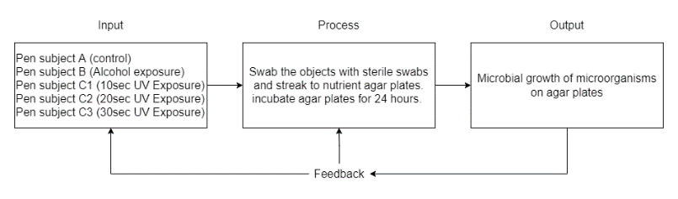***Figure 2.1.1. Conceptual Framework***

The researchers lead up to the following hypothesis. There is no significant difference between ultraviolet-based disinfectant and alcohol-based disinfectant in terms of their effectiveness. There is no significant effect of ultraviolet intensity to be use in terms of its effectiveness. There is no significant difference among the duration of 10 seconds, 20 seconds, and 30 seconds in terms of its effectiveness. The automatic disinfection box does not meet current pandemic situation extremely well. The automatic disinfection box has a very low quality. The automatic disinfection box in terms of price has a poor value for money. The respondents are very dissatisfied using the automatic disinfection box.

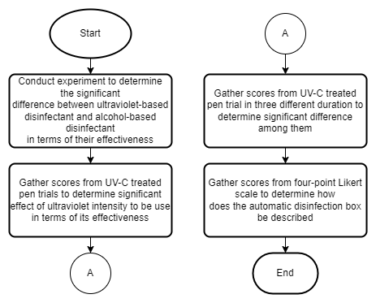

**Figure 2.1.2. Research Design Flowchart**

* 1. **Data Gathering**

The researchers randomly selected 114 respondents by convenience sampling due to limitation of resources. The data for the statement of the problem number three are collected using a google form survey questionnaire after the device is implemented. The survey questionnaire created have questions modified from related research formed by the researchers. The survey covers the necessity, quality, price-quality ratio and approval. The survey was conducted for one month and the researcher’s assured confidentiality of their survey since the identities are not a requirement. The gathered data are used for the research after analyzing the survey answers.

The model development stage consists stages of modeling, design and analysis. The researchers study different sanitation chamber, ultra violet chamber and sanitation device. The researchers ponder that the chamber must have the capability and strength to hold and sanitize objects with size of at least 50cm in height and width. After studying different sanitation chamber models and considering the researchers requirements, the researchers come up with the following model dimension

.

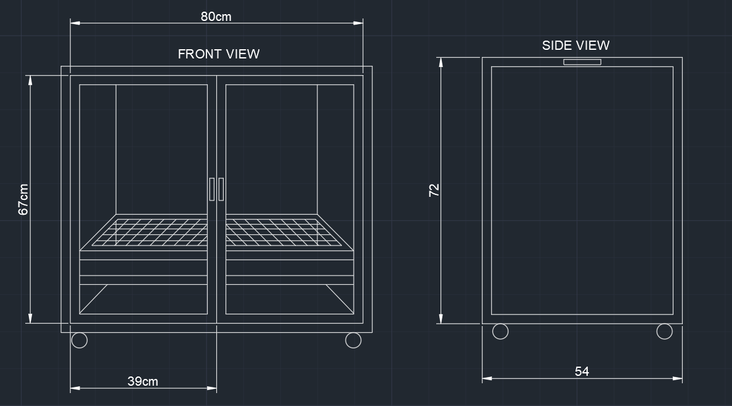

***Figure 2.2.1. Front and Side View of the Device***

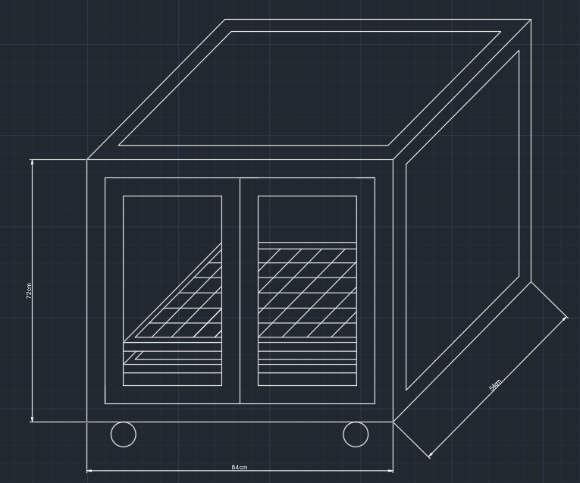

***Figure 2.2.1. 3-Dimensional View of the Device***

The researcher’s requirement must have also that the device is mobile and have the capability to move around effortlessly. the device must also have the capability to smoothly insert objects inside the chamber. The device must also conform to quality standards and have the capability to blend to commercial sanitation chambers in market. The researchers come up with the design in figure 14.

The design analysis data are gathered from the four-point Likert scale Specifically, how does the automatic disinfection box be described in terms of necessity, quality, price-quality ratio and approval.

* 1. **Materials and Specifications**

1. L- bracket or angle bar ¼ x 1 in size.
2. Galvanized steel sheet with measurement of 4x8 in 0.9 thickness.
3. Flat steel bars.
4. Nylon caster wheels (swivel).
5. Galvanized steel matting.
6. ¼ thick clear glass.
7. Stainless cabinet handle.
8. Cylindrical hinges 3/8.
9. Roller catches.
10. Glass silicone sealant.
11. Teks screw.
12. Reflective Insulation foam.
13. Rugby glue.
14. Aerosol paint color white and clear for coating
    1. **Detailed Procedure of Device Implementation**

Angle bars with measurement each of 72, 84 and 54cm. are prepared using angle grinder. A welding machine is use to weld the pieces together into the shape of the frame.

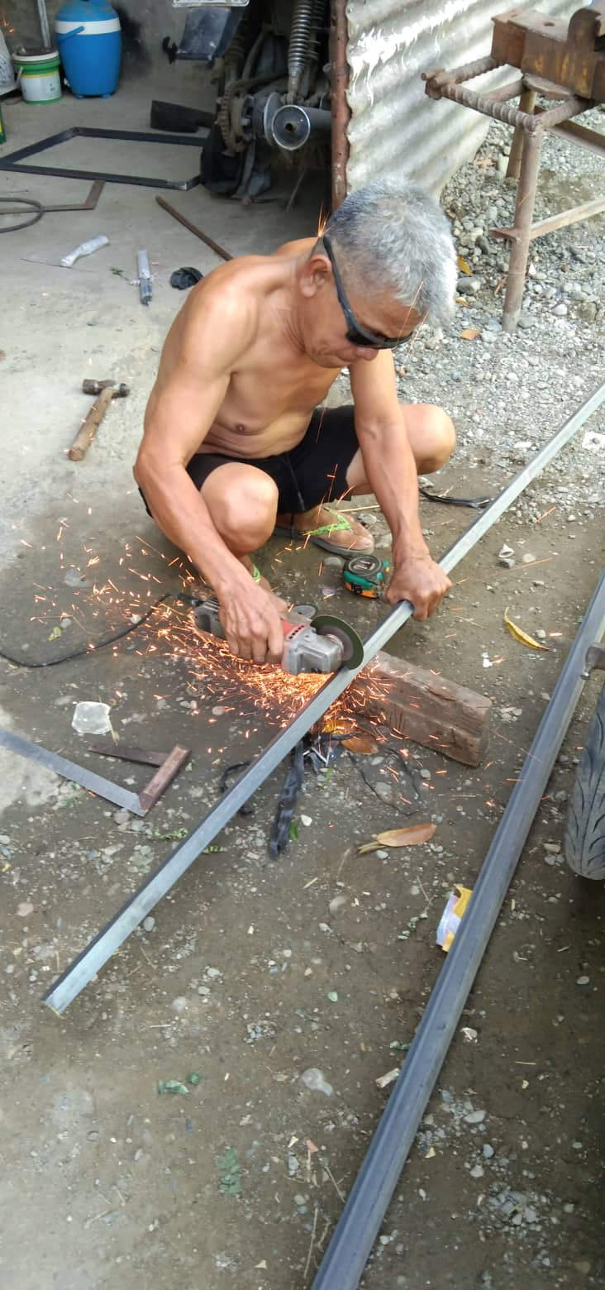

***Figure 2.4.1. Welding of Angle Bars***

Having the rigid frame, the frame is turned upside down to weld the caster wheels on each corner of the frame as to give the frame maneuverability.

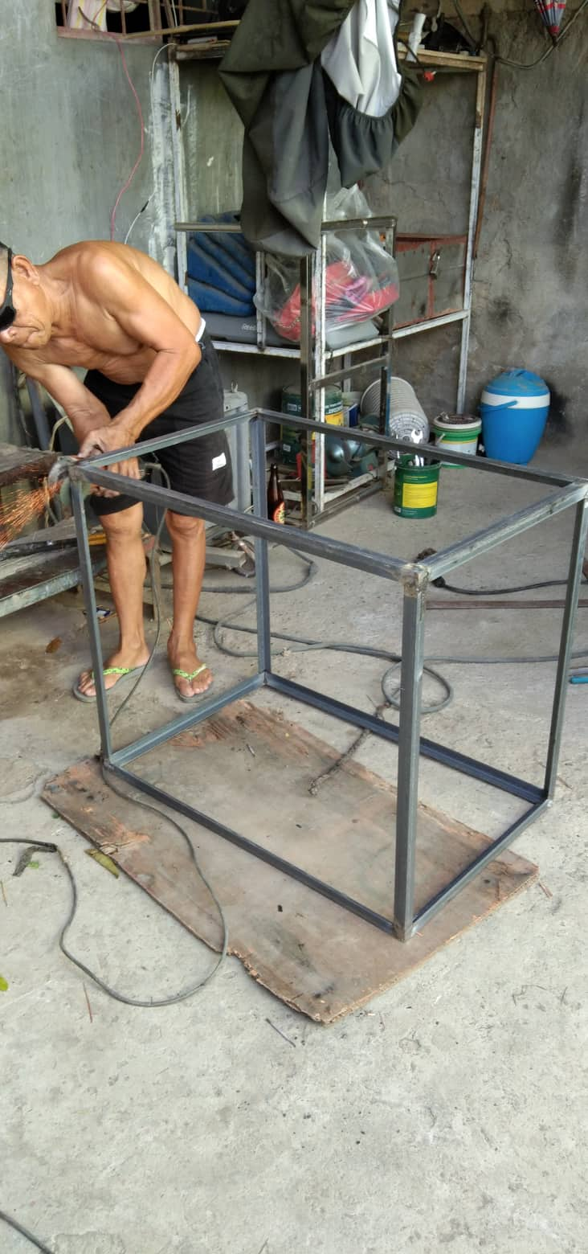

Figure 2.4.2. **Rigid Frame**

A 39 and 67cm angle bars are prepared using the angle grinder and welded into shape of a door frame.

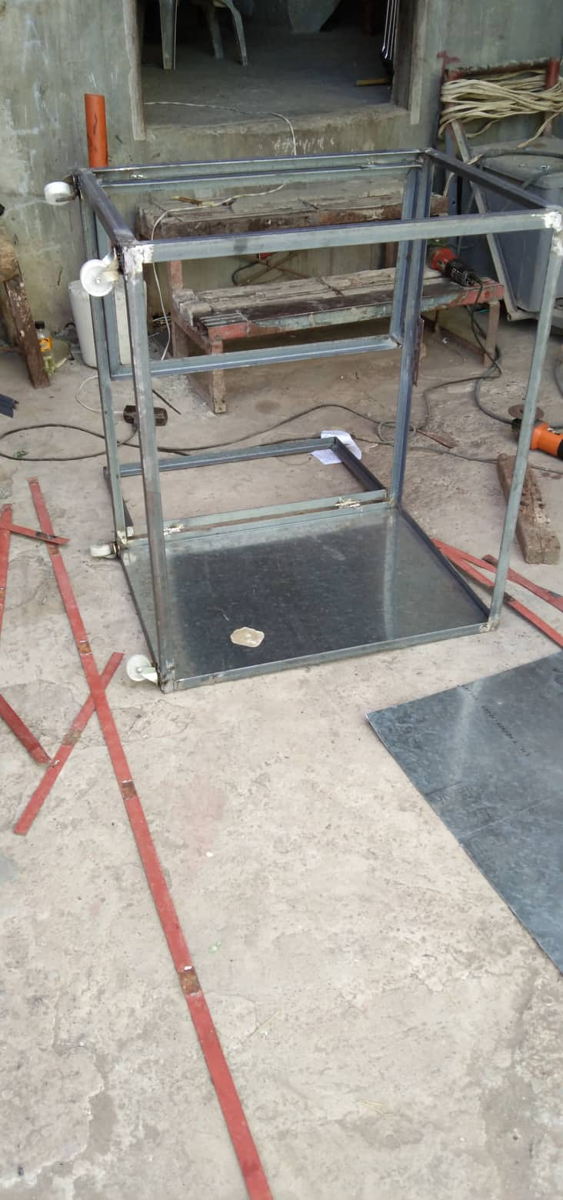

***Figure 2.4.3. Rigid Frame Upside Down***

The door was fixed to the frame using cylindrical hinges. Roller catches are fixed onto the front top and bottom center of the frame.

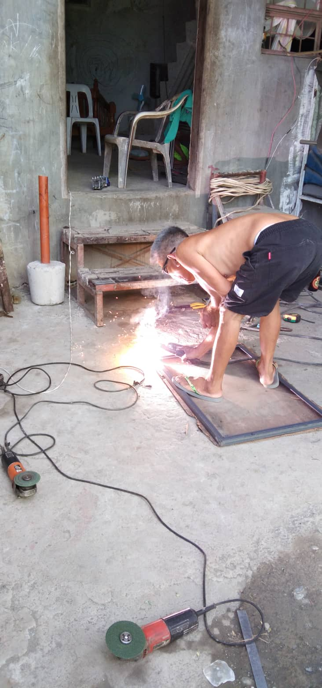

***Figure 2.4.4. Welding of Door Frames***

After turning the frame upright, galvanized steel walls are cut and prepared. Using the welding machine, the steel walls are fixed onto the frame reinforcing with flat bars.

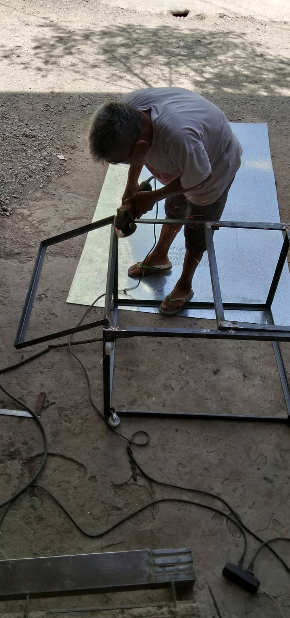

***Figure 2.4.5 Attaching of Door Frames***

Using a measuring tape to have the center of the door frame, two holes were drilled. The aluminum handle bars are screwed onto the frame. Using the same technique, two holes were drilled on the side of the frame and aluminum handle bars are fixed using screws onto the frame.

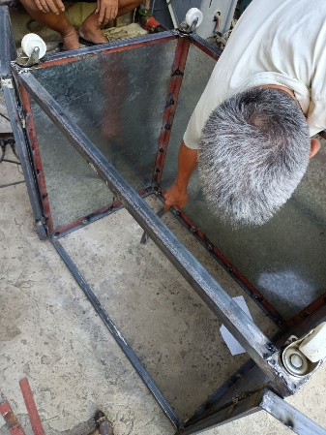

***Figure 2.4.6. Steel Walls***

Using the angle grinder, the frame was sanded off of sharp edges. After smoothing the frame, using aerosol paint, a white coat was applied inside and outside the frame.

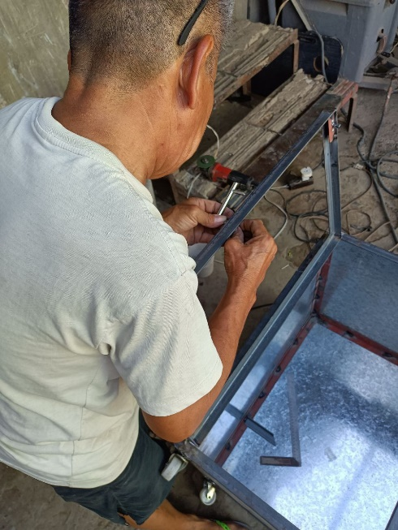

***Figure 2.4.7 Sanding of Rigid Frame***

A clear coat was applied after drying of the primer. A two 49 and 81cm angle bar are prepared and welded into a shape of rectangle and galvanized wire mesh are cut accordingly to the dimension and welded onto the shape. The mesh, who serves as the object holder are coated with primer and clear coat also.

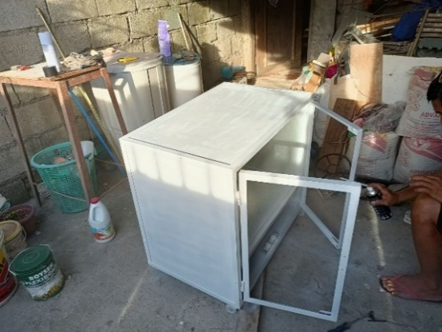

***Figure 2.4.8. Applying Aerosol Paint***

The wire mesh and the circuit chamber divider are fixed onto the inside of the frame using teks screw.

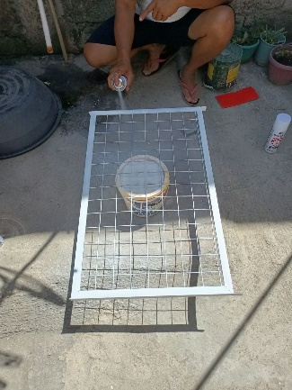

***Figure 2.4.9 Mesh Panel***

¼ inch thick clear glass are fixed onto the door frame using glass silicon putty.

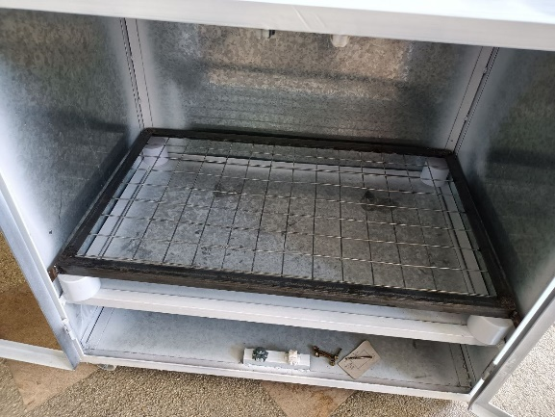

***Figure 2.4.10 Fixed Mesh Panel***

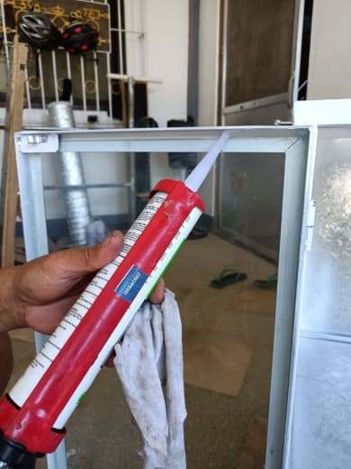

***Figure 2.4.11 Applying Silicon***

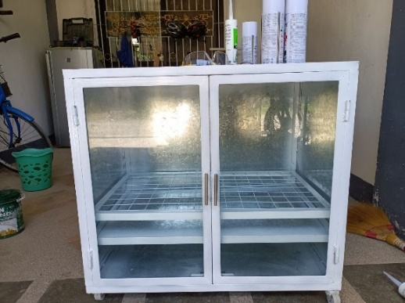

***Figure 2.4.12 Automatic Disinfection Box***

* 1. **Block Diagram**

The figure below shows the block diagram of the circuit.

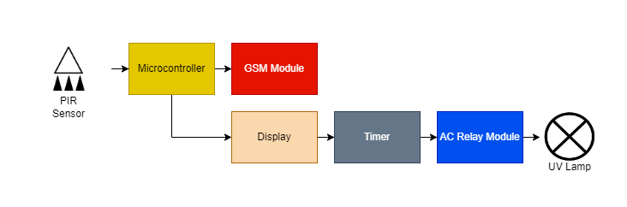

**Figure 2.6.1. Block Diagram**

* 1. **Flowchart**

The figure below shows the flowchart of the circuit.

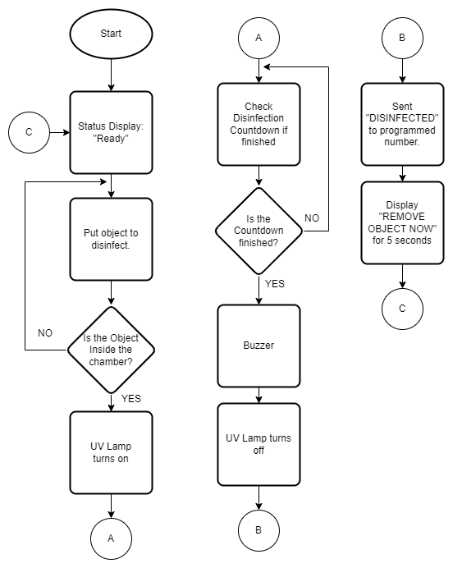

**Figure 2.6.1. Circuit Flowchart**

**2.7 Component Analysis**

The researchers’ components of the proposed system are Arduino uno r3 for microcontroller board. AC relay module kit with outlet plug and wire for Arduino control of 220v AC load, 10 ohms and 100 ohms resistors, passive infrared sensor, a I2C LED display 16x2 IC2, GSM module, sim900 GPRS shield, wire, 5v power supply and Firefly Yellow Shield Antivirus and Germicidal UV Tube Set.

Arduino Uno R3 is a 14 input/output pinned microcontroller which has a 16-Megahertz ceramic resonator, USB connection, a power jack, an ICSP header and a reset button. This is a microcontroller that can be programmed and as such, can be the only microcontroller you will ever need in creating complicated systems.

Arduino Uno can only handle up to 5 volts and can malfunction when applied at a higher voltage, much more when using 220 AC volts into it. The AC Relay module kit helps the microcontroller to handle up to said voltage that is in the description of the module. In the module used in the project, the researchers specifically used a 220v AC load.

Resistors are static components that help regulate the current running in a circuit. The higher the resistance(ohms), the lesser the current(amp). In the project, the researchers specifically used 10 ohms and 100 ohms values of resistors.

Passive Infrared Sensors or PIR Sensors is used to detect an object that is in front of it and act as a switch to a circuit. It activates the circuit when the object is detected by the infrared. This is commonly used in automatically triggered lighting devices and protection systems. In the project, the researchers used it as a detector for the object or item placed inside the chamber to automatically start the disinfection process.

LED Displays are displays that are commercially used in the market because of their efficiency and low-energy consumption. These displays are made up of a series of LED panels which contain LEDs that can be used in a variety of ways from providing light to sending a message. The researchers used a Grove, 16x2 LED display which can be programmed with the use of Arduino Uno and is used to display the status of the disinfection process.

GSM (Global System for Mobile Communications) Module is a chip that can be used to provide the option to send SMS (short messages service) messages in a system. This chip has an antenna to receive and send out transmissions and a slot for the sim card which will be used to send out messages to other devices. The sim900 GPRS shield is the specific model used by the researchers. Despite the small size of the model, this packs many features and is one of the latest models.

The circuit created by the researchers is connected by copper wires. Copper wires are most commonly used in circuits for its conductivity and these wires are covered by rubber for insulation.

Power supplies are components that supply power to at least one load. This is used to provide and regulate a consistent value of current to a load to avoid any inconsistency to the load that can cause complications and malfunctions for the load. The researchers used specifically a 5v power supply that is used to supply power to the Arduino Uno.

UV lights are lights that are capable of disinfecting surfaces within a prolonged period of time under a specific range of intensities. The researchers used Firefly Yellow Shield Antivirus and Germicidal UV Tube Set which has an intensity of 222 nm, operates at a 230 V at 60 Hz, and covers the range of 15 to 20 square meters.

According to felcostore (2022), the FYL201 disinfects, sterilizes, kills bacteria, germs and viruses, coronavirus, influenza virus, mites, anthrax, Hepa B, and dysentery bacteria. The FYL201 disinfecs e-coli, staphylococcus aureus, candida albicans, pseudomonas aeruginosa.

The FYL201 is a quartz lamp cap, filament core, mercury pill lamp type with a UVC length of 222nm. It has an operating voltage of 230V - 60Hz. With an 15-20 sqm coverage area and a dimension of 624 x 48 x 70mm (felcostore, 2022).

According to the Americanultraviolet (2022), Germicidal UVC lamps do not produce much heat and about the same as fluorescent lamps. fluorescent lamps don’t use resistance to emit light, they emit about 75% less heat than an incandescent bulb. As a result, they save energy and keep whatever room they’re in at a cooler temperature.

* 1. **Schematic Diagram**

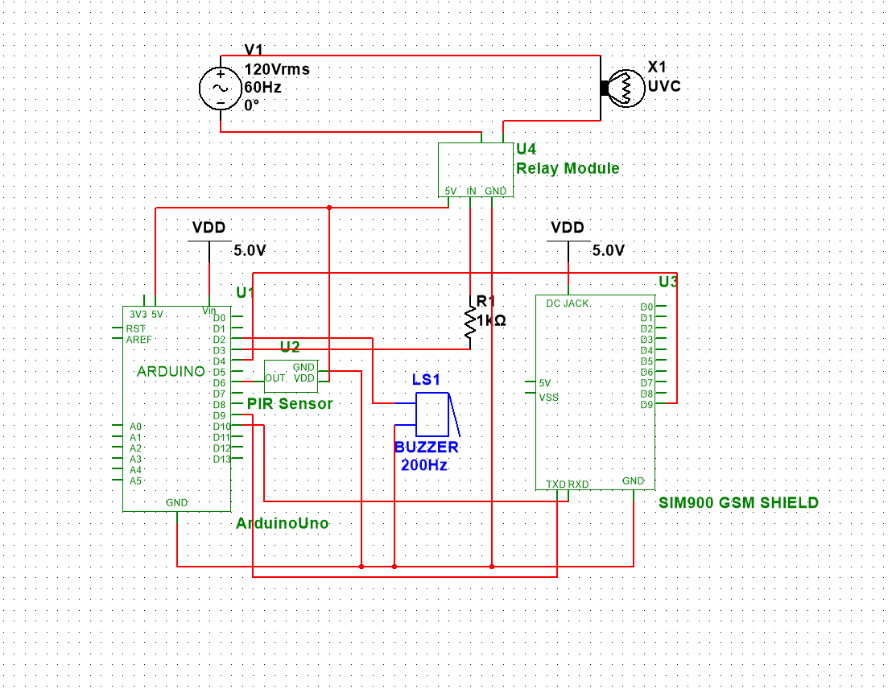

**Figure 2.7.1. Schematic Diagram**

* 1. **Fabrication of the Device**

Connect the GND pins of PIR Sensor, Buzzer, SIM900, and Relay Module to the GND pin of Arduino. Then, connect the source pin of PIR Sensor and Relay Module to the 5V pin of Arduino. After that, connect the TXD and RXD pins of SIM900 to pins 9 and 10 of Arduino respectively. Connect pin 2 of Arduino to the positive pin of the buzzer, then connect the OUT pin of PIR Sensor to pin 6 of Arduino. After that, connect the pin 9 of SIM900 to pin 4 of Arduino. And then connect the pin 3 of Arduino to a 1k resistor then connect the other end of the resistor to the IN pin of Relay Module. Lastly, connect an AC source to the relay module to power up the UVC lamp.

The circuit is soldered in a printed circuit board and placed in the circuit box of the automatic disinfection box.

* 1. **Field Experiment**

To compare the effectiveness of alcohol-based and UV-based disinfection, Ms. Jerimi Francisco together with the researchers conduct streak and spread plate analysis on an empty sterile room in Camp Tinio, Nueva Ecija.

Four similar pens are prepared a day before and equally exposed to normal condition. Nutrient agar is prepared by adding 17.5g of premixed nutrient agar and 482.5mL of distilled water to obtain 500g agar solution. The solution is mixed and bring to a boil. After 5mins of non-stop stirring, the pot is removed from the heat to cool poured the solution to jars and pressured cook for 45mins at 15psi. The jars are removed from the pressure cooker, let it cool to 50 C and poured to prepared petri dishes. Five agar plates with three replications are prepared. Agar plate A (control), plate B (Alcohol exposure), plate C1 (10sec UV exposure), plate C2 (20sec UV exposure) and plate C3 (30sec UV exposure).

For plate A, pen 1 is not exposed to alcohol and UV disinfection. Using sterile medical swab, pen 1 surface is swab. After the hardening of the agar, using streak plate method, the agar is swab with it. The plate is secured then with cling wrap. The same procedure is done with the replications.

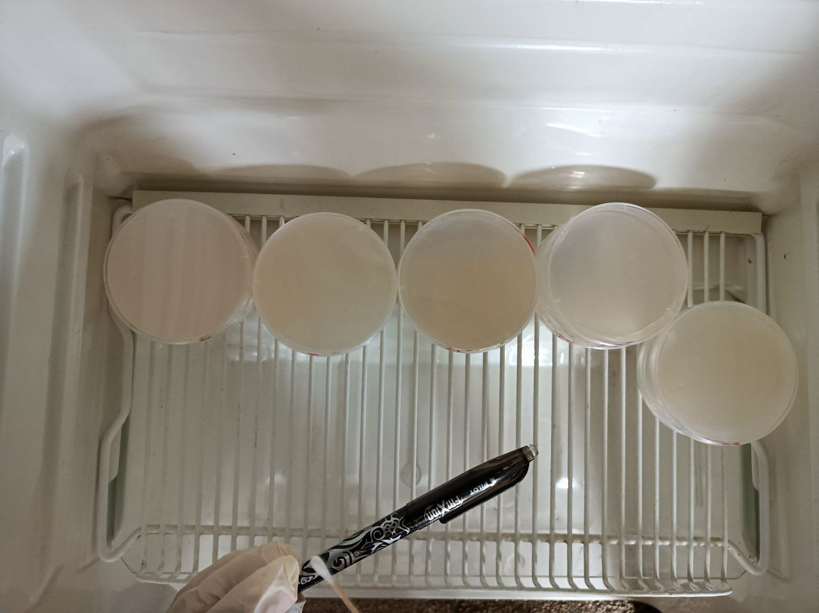

**Figure 2.9.1. Swabbing of Pen 1**

For plate B, pen 1 is swab with sterile L-shaped rod, using the rod, agar plate is prepared using spread plate technique. After the hardening of the agar, four paper filter punchlets soaked in 70% isopropyl alcohol are put to the four quadrants of the agar (disk diffusion method). The same procedure is done for the replications.

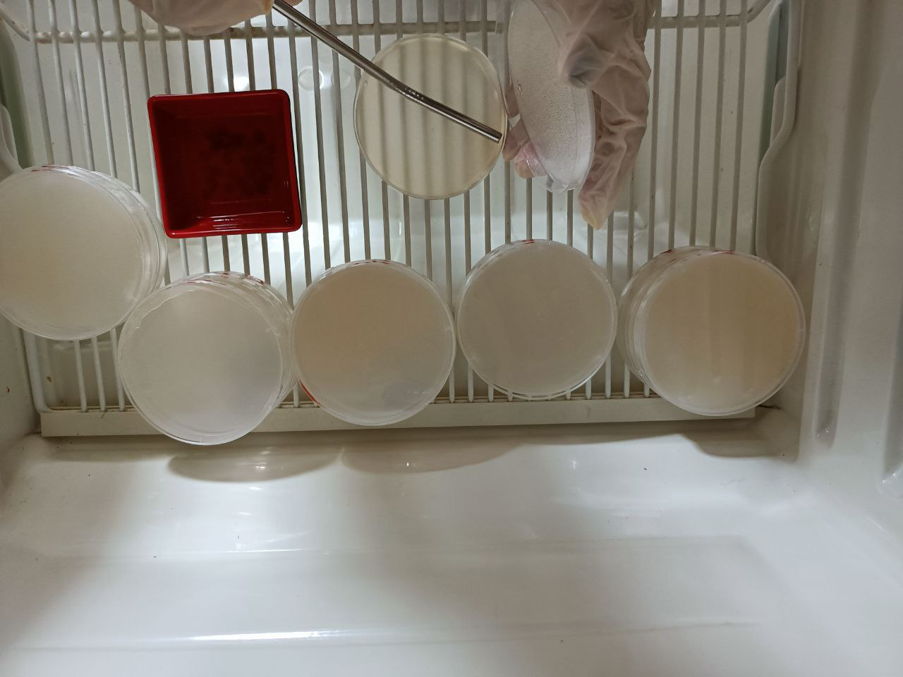

**Figure 2.9.2. Disk Diffusion on Plate B**

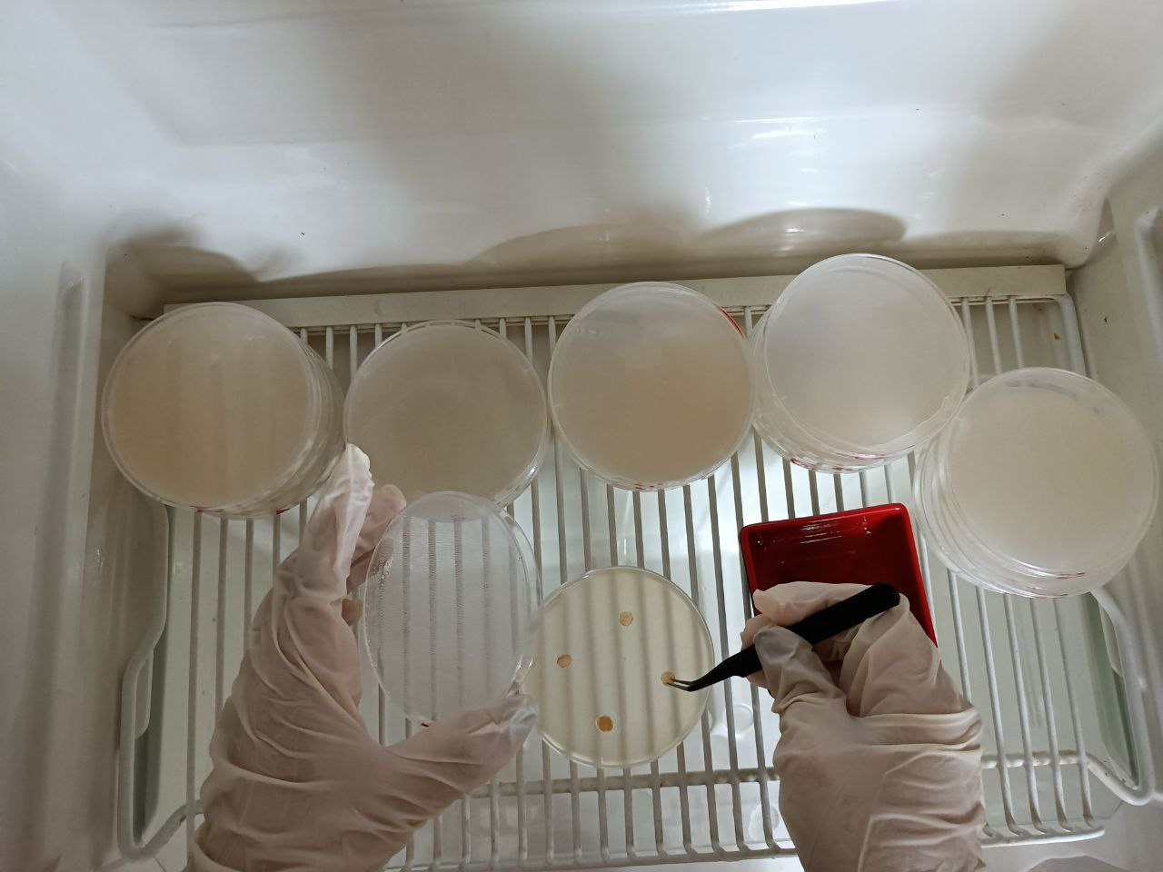

**Figure 2.9.3. Alcohol Punchlets on Plate B**

For plate C1, pen 2 is disinfected using the automatic disinfection for 10 seconds. Using sterile medical swab, the surface of the pen is swab. The plate C1 is swab using streak plate technique. The plate is secured with cling wrap. The same procedure was done with the replications.

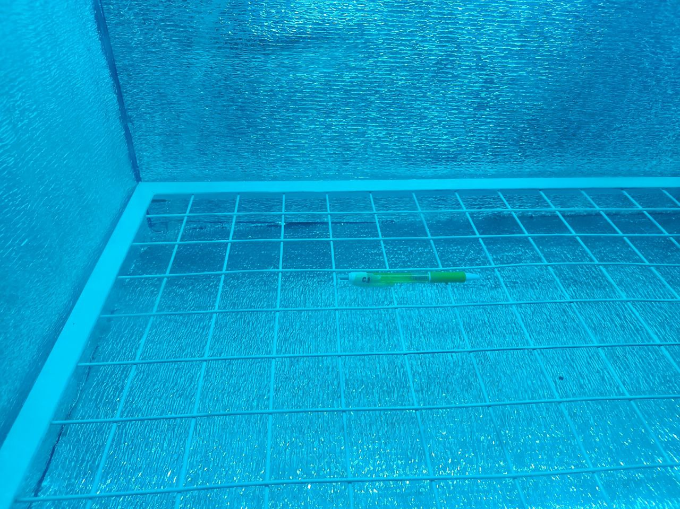

**Figure 2.9.4. UVC Exposure of Pen 2**

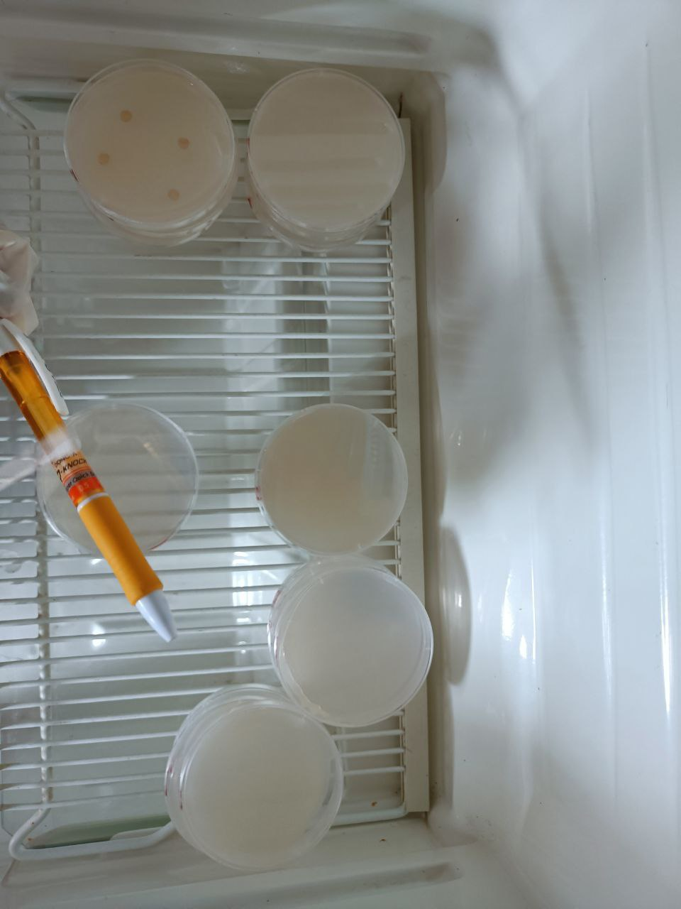

**Figure 2.9.5 Swabbing of Pen 2**

For plate C2, pen 3 is disinfected using the automatic disinfection for 20 seconds. Using sterile medical swab, the surface of the pen is swab. The plate C2 is swab using streak plate technique. The plate is secured with cling wrap. The same procedure was done with the replications.

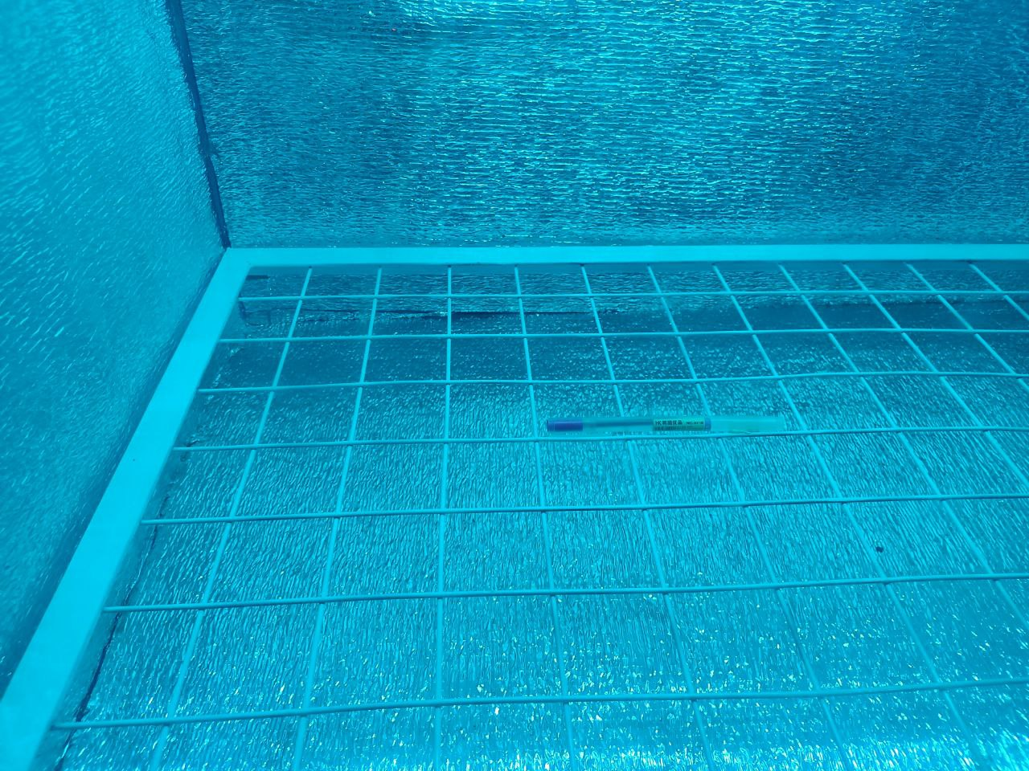

**Figure 2.9.6. UVC Exposure of Pen 3**

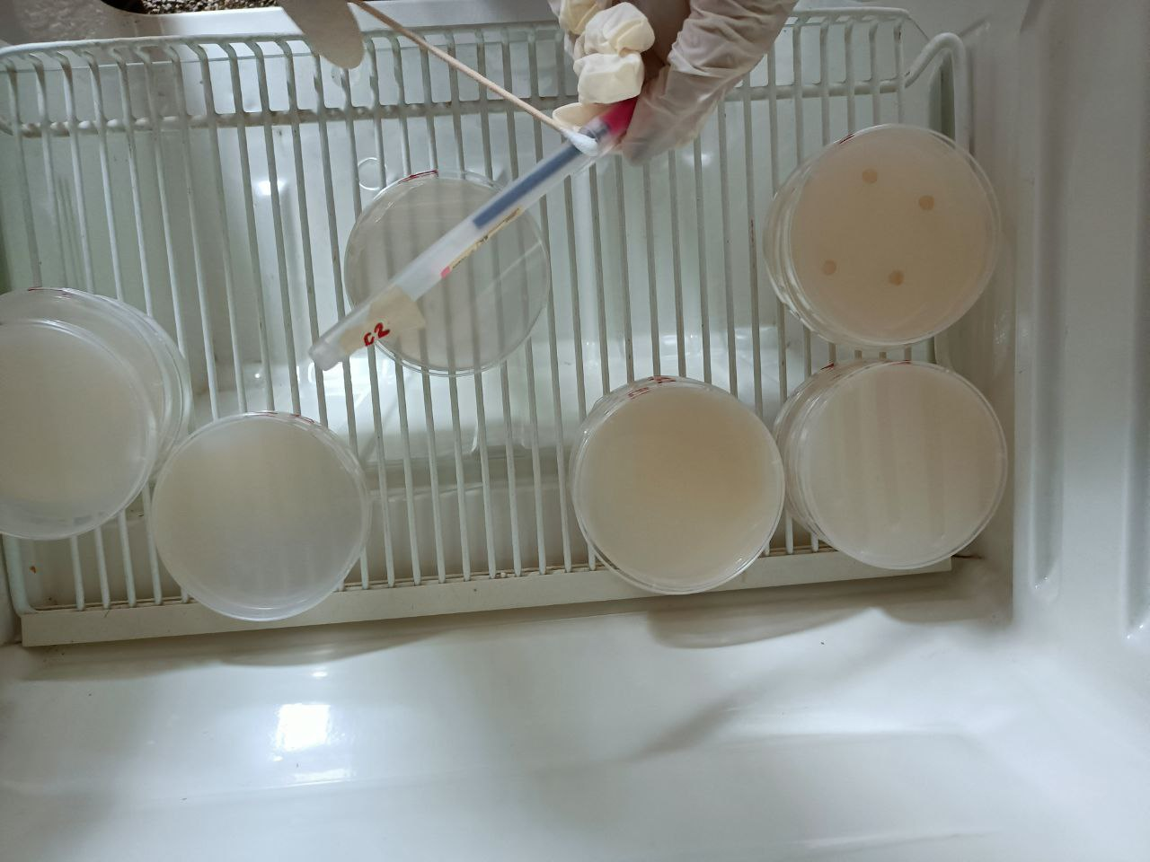

**Figure 2.9.7. Swabbing of Pen 3**

For plate C3, pen 4 is disinfected using the automatic disinfection for 30 seconds. Using sterile medical swab, the surface of the pen is swab. The plate C3 is swab using streak plate technique. The plate is secured with cling wrap. The same procedure was done with the replications.

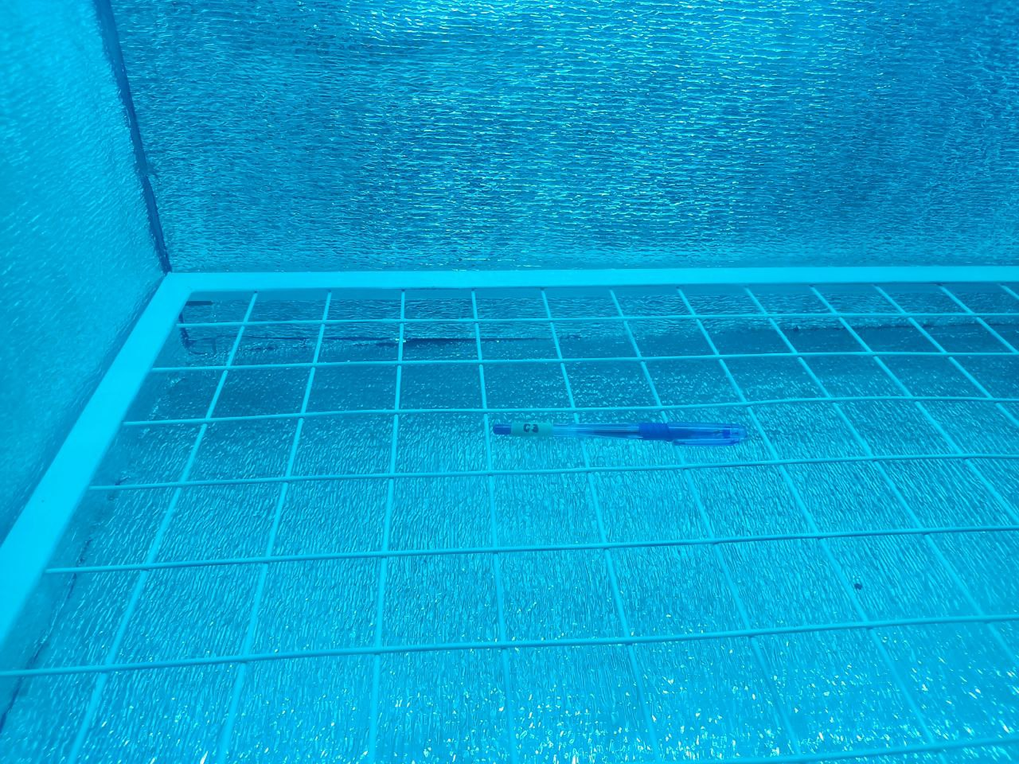

**Figure 2.9.8. UVC Exposure of Pen 4**

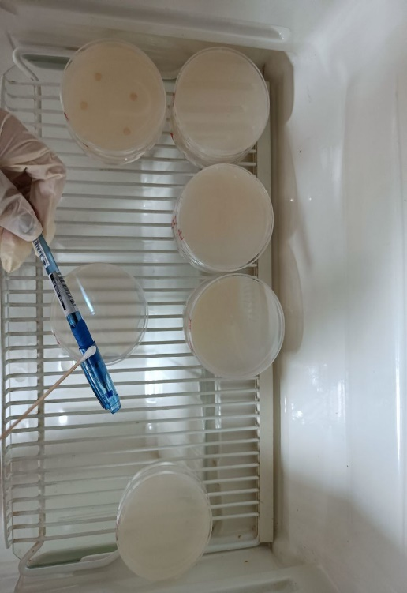

**Figure 2.9.9. Swabbing of Pen 4**

# RESULTS AND DISCUSSION

**Statistical Analysis of UV Based and Alcohol Disinfectant Data.**

All statistical analyses were performed using R Studio v 4.2.1 and all test of significance were evaluated at 5% level provided by Cuevas R. V. (2022).

Effectiveness of UV based and Alcohol based disinfectant were measured based on number of colonies in different treatments. Different treatments were replicated thrice and were compared to a baseline treatment wherein the agar plate was not exposed to UV or Alcohol. Results revealed that the baseline treatment was relatively higher compared to Alcohol based and UV based treatments. This suggests that Alcohol based and UV based disinfectant were more effective in terms of bacterial inhibition.

**Statement of the Problem 1.** What is the significant effect of ultraviolet intensity to be use in terms of its effectiveness?

***Null Hypothesis*.** There is no significant effect of UV intensity to be use in terms of effectiveness.

***Alternative Hypothesis*.** There is a significant effect of UV intensity to be use in terms of effectiveness.

***Result of One-Sample Wilcoxon Test.***

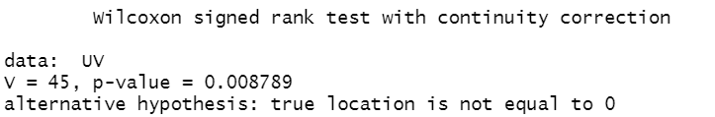

Figure 33. **One Sample Wilcoxon Test**

***Conclusion.*** Since the One-Sample Wilcoxon Test resulted a p-value of 0.0088, and is less than 5% level of significance (0.05), it was therefore concluded that UV intensity has a significant effect in terms of effectiveness. This result supports the comparison of findings of Baseline treatment and UV based treatments in terms of bacterial inhibition since number of colonies from UV based treatments were lower than those from the former.

**Statement of the Problem 2.** What is the significant difference among the different duration in terms of its effectiveness?

***Null Hypothesis*.** There is no significant difference among the duration of 10 seconds, 20 seconds, and 30 seconds in terms of its effectiveness.

***Alternative Hypothesis*.** There is a significant difference among the duration of 10 seconds, 20 seconds, and 30 seconds in terms of its effectiveness.

***Result of Kruskal-Walis Test.***

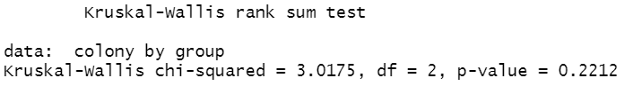

Figure 34. **Kruskal-Walis Test**

***Conclusion.*** Since the Kruskal-Walis test yields a p-value of 0.2212, and is greater than 5% level of significance (0.05), therefore, the different durations of UV exposure show no significant difference in terms of effectiveness.

**Statement of the Problem 3a.** How does the automatic disinfection box be described in terms of necessity, quality, price-quality ratio, and approval?

***Statistical Analysis of Responses in terms of Necessity.***

The following table shows the statistical mean of the responses.

**Response Mean in terms of Necessity**

|  |  |  |
| --- | --- | --- |
| **Survey Question** | **Weighted Mean** | **Verbal Description** |
| How well does the device meet current pandemic situation needs? | 1.36 | Extremely Well |

In terms of necessity, the mean value of 1.36 falls under the statistical range of 1 – 1.74 with the verbal interpretation of Extremely Well.

***Statistical Analysis of Responses in terms of Quality.***

The following table shows the statistical mean of the responses.

Table 3

**Response Mean in terms of Quality**

|  |  |  |
| --- | --- | --- |
| **Survey Question** | **Weighted Mean** | **Verbal Description** |
| How would you rate the quality of the device? | 1.43 | Very High Quality |

In terms of quality, the mean value of 1.43 falls under the statistical range of 1 – 1.74 with the verbal interpretation of Very High Quality.

***Statistical Analysis of Responses in terms of Price-Quality Ratio.***

The following table shows the statistical mean of the responses.

**Response Mean in terms of Price-Quality Ratio**

|  |  |  |
| --- | --- | --- |
| **Survey Question** | **Weighted Mean** | **Verbal Description** |
| With a price of 9,500 PHP, how would you rate the value for money of the device? | 2.15 | Above Average |

In terms of price-quality ratio, the mean value of 2.15 falls under the statistical range of 1.75 - 2.49 with the verbal interpretation of Above Average.

***Statistical Analysis of Responses in terms of Approval.***

The following table shows the statistical mean of the responses.

**Response Mean in terms of Approval**

|  |  |  |
| --- | --- | --- |
| **Survey Question** | **Weighted Mean** | **Verbal Description** |
| Overall, how satisfied or dissatisfied are you using the device or if you use the device? | 1.49 | Very Satisfied |

In terms of approval, the mean value of 1.49 falls under the statistical range of 1 – 1.74 with the verbal interpretation of Very Satisfied.

***Statistical analysis of Statement Problem 3.***

The following table shows the summary of the statistical mean of the responses.

**Overall Survey Question Response Mean**

|  |  |  |  |
| --- | --- | --- | --- |
| **Statement of the Problem** | **Corresponding Survey Question** | **Weighted Mean** | **Verbal Description** |
| How does the automatic disinfection box be described in terms of necessity? | How well does the device meet current pandemic situation needs? | 1.36 | Extremely Well |
| How does the automatic disinfection box be described in terms of quality? | How would you rate the quality of the device? | 1.43 | Very High Quality |
| How does the automatic disinfection box be described in terms of price-quality ratio? | With a price of 9,500 PHP, how would you rate the value for money of the device? | 2.15 | Above Average |
| How does the automatic disinfection box be described in terms of Approval? | Overall, how satisfied or dissatisfied are you using the device or if you use the device? | 1.49 | Very Satisfied |
| **Overall Mean** | 1.61 | | |
| **Respondents** | 114 | | |

**Device Description Analysis.**

The researchers use convenience sampling as a non-probability sampling method due to resource limitation in collecting feedback. The method yields a total 114 responses. The researchers adapt Cuevas R. V (2022) four-point Likert scale, where value one leans to strongly agree and value four leaning to strongly disagree.

**Statement of the Problem 4.** Is there a significant difference between ultraviolet-based disinfectant and alcohol-based disinfectant in terms of their effectiveness?

***Null Hypothesis.*** There is no significant difference between UV based disinfectant and Alcohol based disinfectant in terms of their effectiveness.

***Alternative Hypothesis.*** There is a significant difference between UV based disinfectant and Alcohol based disinfectant in terms of their effectiveness.

***Result of Two-Samples Wilcoxon Test.***

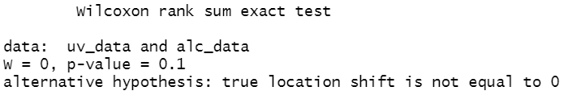

Figure 32. **Two Sample Wilcoxon Test**

***Conclusion.*** Since the p-value of 0.1 is greater than 5% level of significance (0.05), there is enough evidence to conclude that UV and Alcohol based disinfectant exhibit no significant difference when it comes to their effectiveness.

1. **Summary, Conclusion and Recommendations**

The following conclusion were made based on the findings, proof of effectivity of the device such as certificate of analysis of Automatic Disinfection Box and Certification of Statistical Treatment

There is enough evidence to conclude that UV and Alcohol based disinfectant exhibit no significant difference when it comes to their effectiveness. UV intensity has a significant effect in terms of effectiveness and this result supports the comparison of findings of Baseline treatment and UV based treatments in terms of bacterial inhibition since number of colonies from UV based treatments were lower than those from the former, and the different durations of UV exposure of 10, 20, 30 seconds show no significant difference in terms of effectiveness.

Based on the statistical analysis, the automatic disinfection meets current pandemic situation extremely well, the automatic disinfection box has a very high quality in terms of quality, have an above average price-quality price ratio and the respondents are very satisfied using the automatic disinfection box.

1. **Recommendations**

The researchers recommend the following suggestions to further develop and revolutionize the study.

1. Make a real-time UVC dosage monitor module that shows the current UVC dosage of the device producing.
2. Develop a BIOS of the system to save the current settings, device health, UVC lamp life.
3. Improve by letting maintainer input their mobile phone number where the device is going to send the message. The length of the message can also be improved by adding more information to the message.
4. Add feature that when the registered number of the device received a “STATUS” the device will send the current status of the device.
5. Expand device by a self-disinfect feature on the device handles to reduce transmission of virus and microorganisms.
6. Construct buttons to the device like power switch to make it more intuitive.

# REFERENCES

1. Acasestudy (2021). What is qualitative research design? Methods and types. Retrieved from https://acasestudy.com/what-is-qualitative-research-design-methods-and-types/
2. AIS (2022). How to choose the right beam angle for LED lights. Retrieved from https://www.aisledlight.com/choose-right-beam-angle-led-lights/
3. Aisha et. Al (2018). Effect of ultraviolet radiation on the growth of microorganisms developing on cave wall paintings. Retrieved from https://aip.scitation.org/doi/abs/10.1063/1.5048178?journalCode=apc#:~:text=UV%2DC%20at%20a%20wavelength,the%20end%20of%20the%20treatment.
4. Alba et. Al. (2021). Microbiological Evaluation of the Disinfecting Potential of UV-C and UV-C Plus Ozone Generating Robots. Retrieved from https://www.mdpi.com/2076-2607/9/1/172
5. American Ultraviolet. frequently Asked Questions about UVC. Retrieved from https://www.americanultraviolet.com/germicidal-healthcare-solutions/frequently-asked-questions-about-UVC.html
6. Arduino.cc (2022). UNO R3. Retrieved from https://docs.arduino.cc/hardware/uno-rev3
7. Baes, F. (n.d.). Hps.org. Health Physics Society. Retrieved July 24, 2022, from https://hps.org/publicinformation/ate/q9450.html
8. Barnard et. Al. (2020). Further Evidence That Far-UVC for Disinfection Is Unlikely to Cause Erythema or Pre-Mutagenic DNA Lesions in Skin. Retrieved from https://doi.org/10.1111/phpp.12580.
9. Bhandari P. (2020). An introduction to quantitative research. Retrieved from https://www.scribbr.com/methodology/quantitative-research/
10. Brenner D. (2020). Far-UVC Light to Limit Airborne Transmission of SARS-CoV-2 … and All Other Viruses. Retrieved from https://www.nationalacademies.org/event/09-16-2020/the-second-gilbert-w-beebe-webinar-safety-and-efficacy-of-uvc-to-fight-covid-19.
11. Buonanno, M. (2020, December 23). Far-UVC light (222ânm) efficiently and safely inactivates airborne human coronaviruses. Scientific Reports. Retrieved from https://www.nature.com/articles/s41598-020-67211-2
12. Buonanno, M. et. Al. (2019). Germicidal Efficacy and Mammalian Skin Safety of 222-nm UV Light. Retrieved from https://doi.org/10.1667/RR0010CC.1.
13. Buonanno, M. et. Al. (2020). Far-UVC Light (222 nm) Efficiently and Safely Inactivates Airborne Human Coronaviruses. Retrieved from https://doi.org/10.1038/s41598-020-67211-2.
14. Casini, B., & Tuvo, B. (2019, September 24). Evaluation of an ultraviolet C (UVC) light-emitting device for disinfection of high touch surfaces in hospital critical areas. International journal of environmental research and public health. Retrieved July 25, 2022, from https://www.ncbi.nlm.nih.gov/pmc/articles/PMC6801766/
15. Cesarini, J.-P. (2019). UV-C photocarcinogenesis risks from germicidal lamps. CIE. Retrieved July 25, 2022, from https://cie.co.at/publications/uv-c-photocarcinogenesis-risks-germicidal-lamps
16. Childress J. (March 22, 2021). Using 222-nm Ultraviolet (UV) Light for Safer Disinfection. Retrieved from https://www.dsiac.org/resources/articles/using-222-nm-ultraviolet-uv-light-for-safer-disinfection/
17. Dahal (2022). Spread Plate Method- Definition, Principle, Procedure, Uses. Retrieved from https://microbenotes.com/spread-plate-technique/
18. Dahal (2022). Streak Plate Method- Principle, Types, Methods, Uses. Retrieved from https://microbenotes.com/streak-plate-method-principle-methods-significance-limitations/
19. DOST (May 22, 2020). DOST-X, PARAS JOIN HANDS IN DEVELOPING PARAZAP DISINFECTION UNIT FOR COVID-19. Retrieved from https://www.dost.gov.ph/knowledge-resources/news/67-2020-news/1823-dost-x-paras-join-hands-in-developing-parazap-disinfection-unit-for-covid-19.html
20. Electronicsforu.com (2021). All You Wanted to Know About GSM Module and GPRS Module. Retrieved from https://www.electronicsforu.com/resources/gsm-module
21. Eubanas G. et. Al. (2021, February 26). Are ultraviolet lamps effective in infection prevention and control of COVID-19 infections in public spaces in locations with sustained community transmission? Retrieved from https://www.psmid.org/wp-content/uploads/2021/04/NPI_UV-Lamps_20210405.pdf
22. FDA. (2020). Ultraviolet (UV) radiation. U.S. Food and Drug Administration. Retrieved July 25, 2022, from https://www.fda.gov/radiation-emitting-products/tanning/ultraviolet-uv-radiation
23. Felco Store (2022). Firefly Yellow Shield Antivirus & Germicidal UV Tube Set. Retrieved from https://www.felcostore.ph/products/firefly-yellow-shield-antivirus-germicidal-uv-tube-set?variant=42080995639460
24. Felcostore.ph (2022). Firefly Yellow Shield Antivirus & Germicidal UV Tube Set. Retrieved from https://www.felcostore.ph/products/firefly-yellow-shield-antivirus-germicidal-uv-tube-set
25. Geiger D. (2020). UV Light Helps Duke Hospitals Fight Transmission of Superbugs. Retrieved from https://www.dukehealth.org/blog/uv-light-helps-duke-hospitals-fight-transmission-of-superbugs

**ACKNOWLEDGEMENTS**

The proponents would like to express their deepest gratitude to their research advisers, Engr. Jonathan C. Manarang and Engr. Pedrito M. Tenerife Jr. for giving the opportunity to conduct the study with proper guidance and support.

The proponents would also like to extend their gratitude to Department of Science and Technology SEI for their support in our research. Mr. Alberto De Guzman and Samuel M. Saralde, Ms. Jerimi F. Francisco, Reynaldo T. Cuevas V and Hillary Mae L. Almonte for their guidance throughout the duration of the study.

The proponents would also like to thank their families and friends for their unending love, support, and assistance. Lastly, to almighty God for providing the proponents the wisdom, courage, and strength during the study.